**“E-KETHA” : ENRICHING RICE FARMER’S QUALITY OF LIFE THROUGH A MOBILE APPLICCATION.**

2022-81

Project Status Document 1 – Individual

P.Y.D Jayasinghe – IT19117256

Supervisor: Mr. Adeepa Gunarathna

Co Supervisor: Ms. Amali Upeka Gunasinghe

B.Sc. (Hons) Degree in Information Technology

Department of Computer Science and

Software Engineering

Sri Lanka Institute of Information Technology

Sri Lanka

May 2022

**TABLE OF CONTENTS** ii

1. Microsoft Teams Chat and Meetings 1

2. Call of MS Teams 2

3. Microsoft planner overall analysis of tasks 4

4. Work Breakdown Structure 6

5. Grant Chart 7

# Microsoft Teams Chat and Meetings

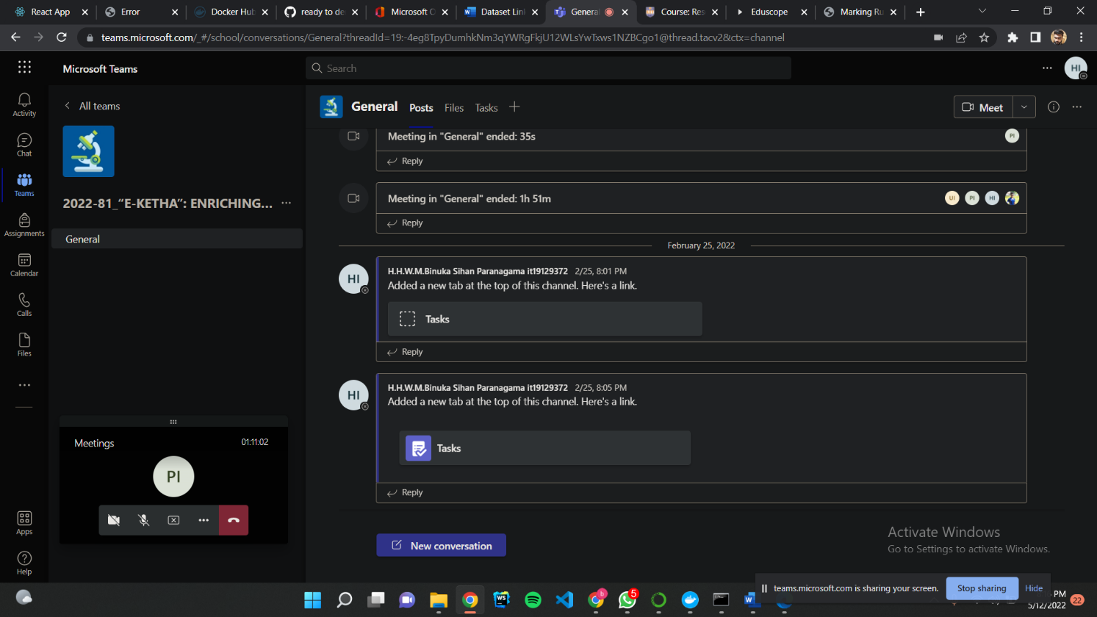

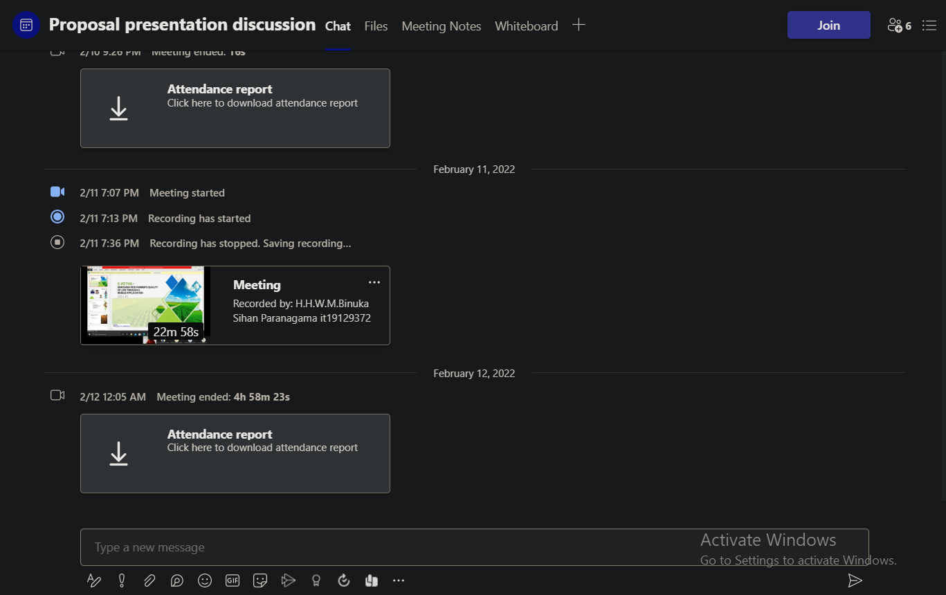

# Call of MS Teams

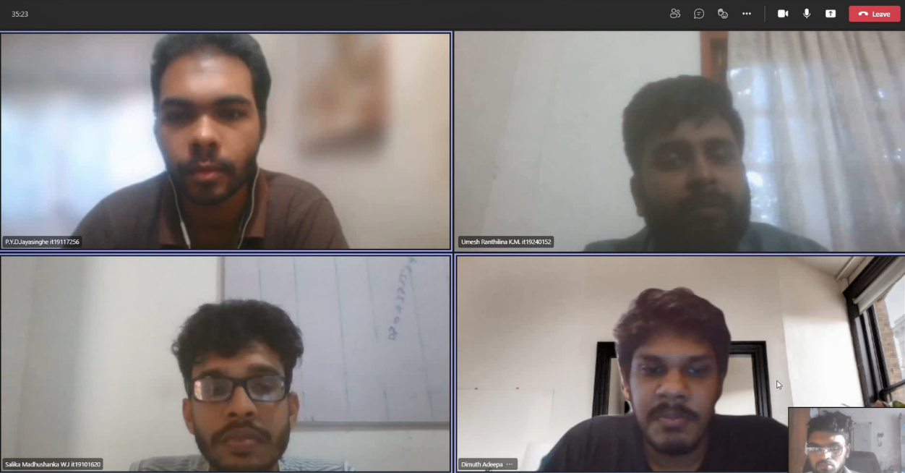

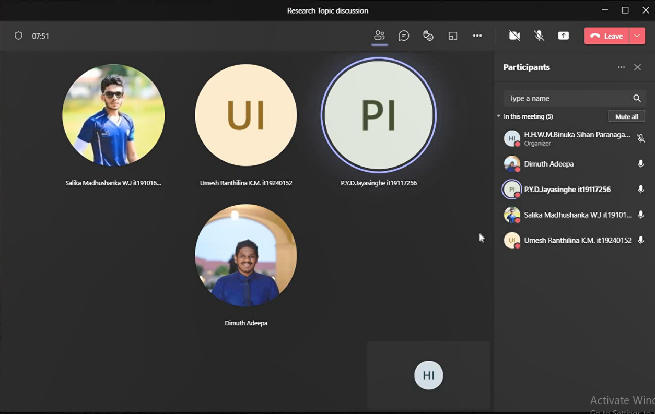

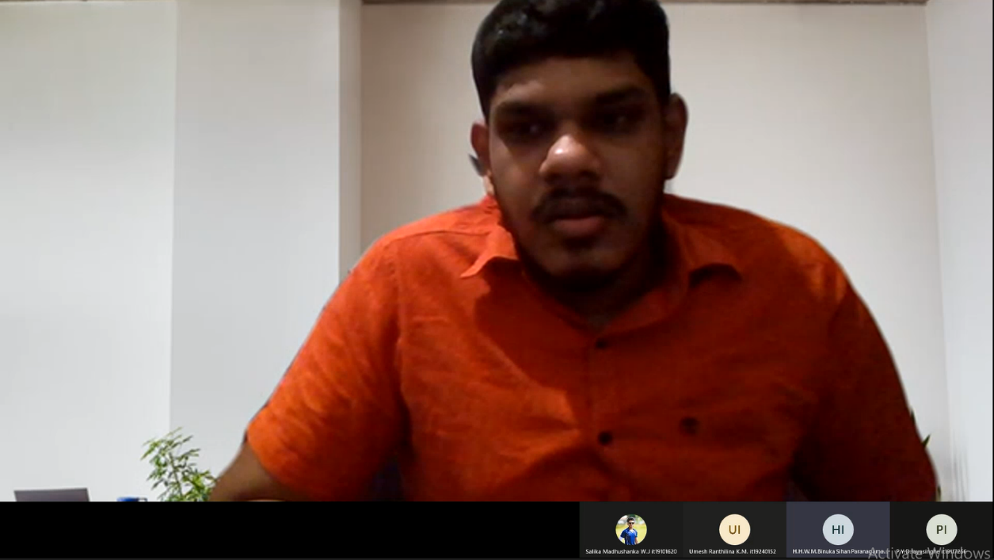

# Microsoft planner overall analysis of tasks

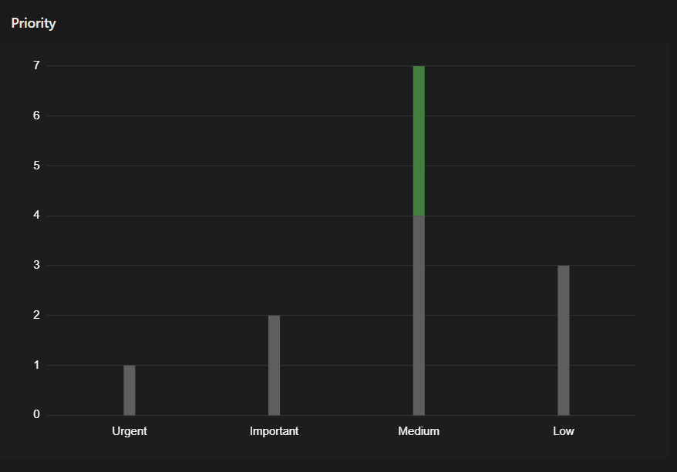

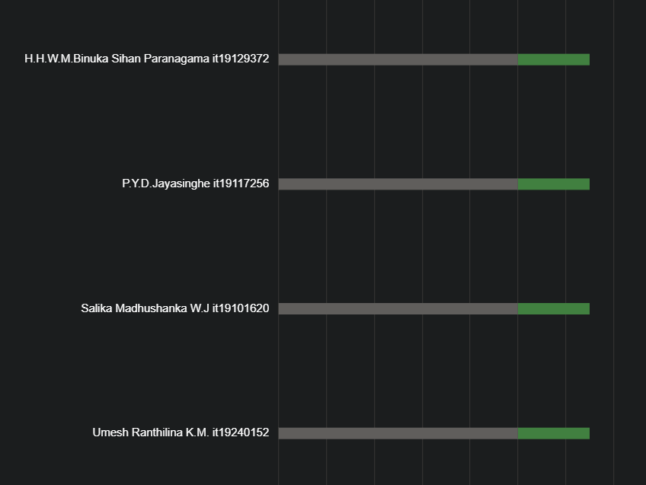

# Work Breakdown Structure

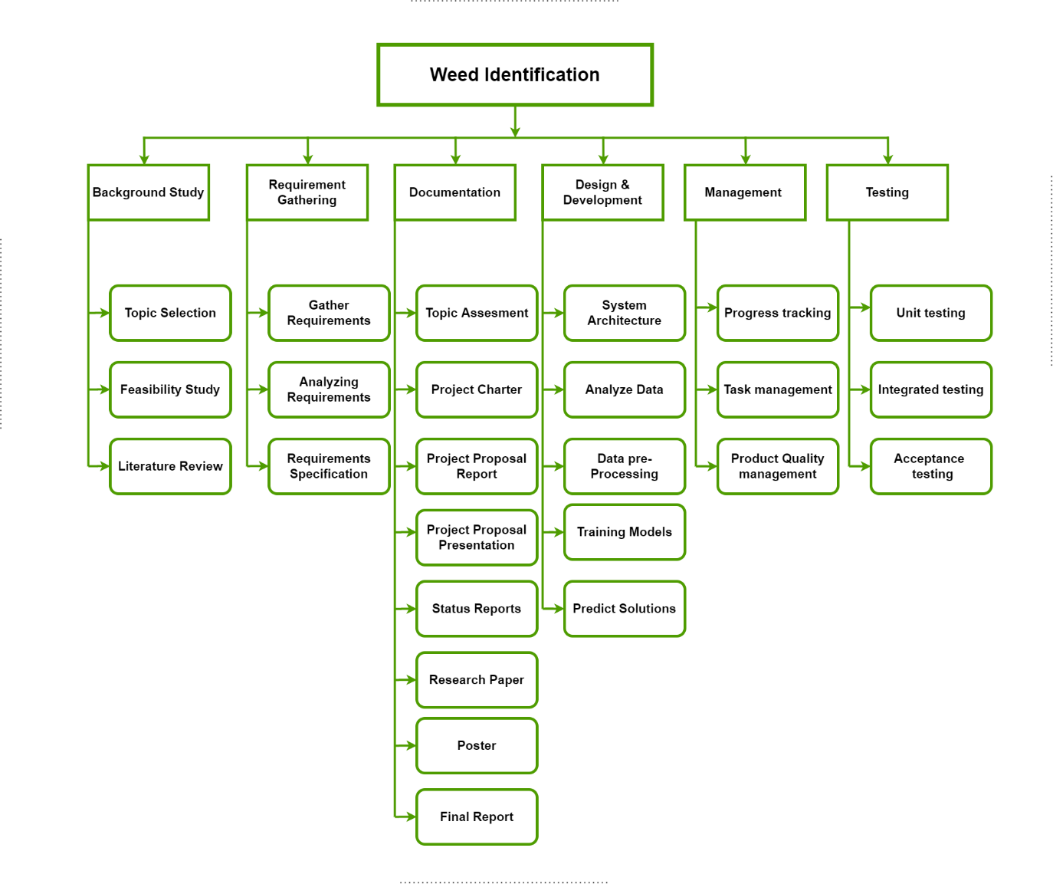

# Grant Chart

